**8. In how many ways can a CSS be integrated as a web page?**

1. **Inline CSS**:

You can include CSS directly within HTML elements using the style attribute.



1. **Internal CSS:-**

You can include CSS within the <style> element in the <head> section of an HTML document.

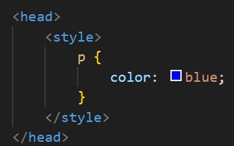

1. **External CSS:-**

You can link an external CSS file to your HTML document using the <link> element in the <head> section.

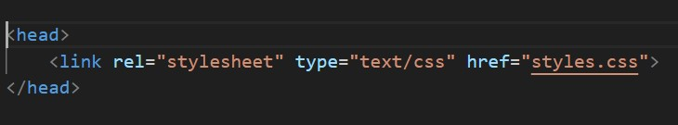

1. **Importing CSS :-**

You can import an external CSS file within another CSS file using the @import rule.

